2010 Chiles Mini Mu Speed Math

- ______ 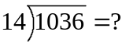

- ______ 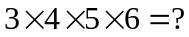

- ______ 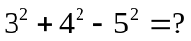

- ______ If 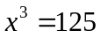, then 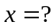

- ______ 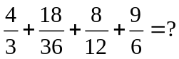
- ______ 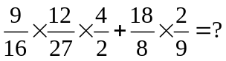
- ______ Rationalize : 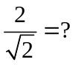
- ______
- ______ 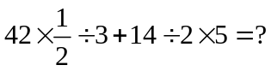
- ______ 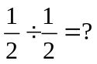
- ______ 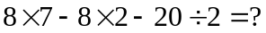
- ______ 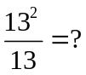
- ______ If one x is worth 3 y’s, and 9 y’s are worth 4 z’s, then how many z’s are 3 x’s worth?
- ______ 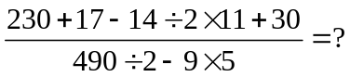
- ______ Simplify : 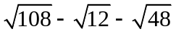

- ______ Solve: 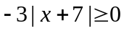

- ______ How many terms are in the sequence 3, 6, 9, …, 21?

- ______ What is the largest three digit number divisible by 3, 4, 5, and 6?

- ______ 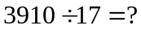

- ______ How many ways can you make change for a dollar using only quarters and nickels?
- ______ Simplify: 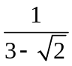
- ______ If one can of paint can cover an area of 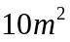, then how many whole cans would a painter need to cover a cube-shaped room with sides of 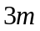, assuming they don’t paint the floor?

- ______ 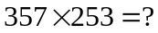

- ______ Find the total outside surface area, in 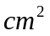, of an open can (a cylinder with no top) with base radius 4cm and height 8cm.

- ______ In a bicycle shop, there are 50 bicycles and tricycles, in total, for sale. If there are a total of 127 wheels, then how many tricycles are there?

- ______ What digit must replace the blank in 56_ to make it evenly divisible by 6?

- ______ What is the sum of the first ten positive even numbers?
- ______ Simplify completely: 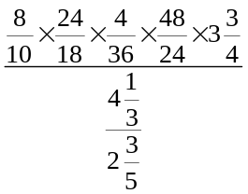
- ______ Find the prime factorization of 3024.

- ______ The value of a purchased stock decreases by 30% the first year, then increases by 10% the second year. What percent value of the original worth is the stock after the second year?

